A Field Project Report on

Online Grocery Store

Submitted

In partial fulfillment of the requirements for the award of the degree

BACHELOR OF TECHNOLOGY

In

COMPUTER SCIENCE and ENGINEERING

By

Avanthika.V ( 231FA04283)
Chandana.J ( 231FA04383)
Moana Venkata Krishna.Ch (231FA04431)
Dharani.G (231FA04548)

Under the Guidance of

MS Nandhini

Assistant Professor, CSE



DEPARTMENT OF COMPUTER SCIENCE & ENGINEERING

SCHOOL OF COMPUTING AND INFORMATICS

VIGNAN'S FOUNDATION FOR SCIENCE, TECHNOLOGY & RESEARCH

(Deemed to be University)
Vadlamudi, Guntur -522213, INDIA.

April, 2025



CERTIFICATE

This is to certify that the field project entitled “Online Grocery Market” is being submitted by [Avanthika], [231FA04283], [Chandana], [231FA04383], [Mohana Venkata Krishna], [231FA04431],and[Dharani], [231FA04548]in partial fulfilment of the requirements for the degree of Bachelor of Technology (B.Tech.) in Computer Science and Engineering at the Department of Computer Science and Engineering, Vignan’s Foundation for Science, Technology and Research (Deemed to be University), Vadlamudi, Guntur District, Andhra Pradesh, India.
This is a bonafide work carried out by the aforementioned students under my guidance and supervision.

Guide

Project Review Committee HoD, CSE



DECLARATION

Date:
We hereby declare that the work presented in the field project titled “Online Grocery Store” is the result of our own efforts and investigations.

This project is being submitted under the supervision of MS. Nandhini, in partial fulfillment of the requirements for the Bachelor of Technology (B.Tech.) degree in Computer Science and Engineering at the Department of Computer Science and Engineering, Vignan’s Foundation for Science, Technology and Research (Deemed to be University), Vadlamudi, Guntur, Andhra Pradesh, India.

Avanthika.V | (231FA04283) | Signature
Chandana.J | (231FA04381.) | Signature
Mohana Venkata Krishna.Ch | (231FA04431) | Signature
Dharani.G | (231FA04548) | Signature

Contents

Chapter No. |  | Description | Page No.
1 |  | Introduction | 5
 | 1.1 | Problem definitions | 5
 | 1.2 | Existing system | 5
 | 1.3 | Proposed system | 6
 | 1.4 | Literature review | 6-7
2 |  | System Requirements | 8
 | 2.1 | Hardware & Software requirements | 8-9
 | 2.2 | Software requirements Specification (SRS) | 9-10
3 |  | System Design | 11-12
 | 3.1 | Modules of system | 12
 | 3.2 | UML Diagrams | 12-13
4 |  | Implementation | 14-15
 | 4.1 | code | 15-61
5 |  | Results | 62
 | 5.1 | Output Screens | 62-65
6 |  | Conclusion | 66
 |  | References | 66

“ONLINE GROCERY STORE”

Introduction:
At our store, we bring fresh, high-quality groceries right to your doorstep with just a few clicks. Our mission is to make grocery shopping easy, convenient, and hassle-free. Whether you're looking for farm-fresh produce, pantry essentials, dairy products, or household items, we've got you covered.
With a user-friendly interface, secure payment options, and fast delivery, we ensure a seamless shopping experience. Browse through our wide range of products, add them to your cart, and get them delivered at your convenience.
we believe in offering our customers not just convenience, but also an exceptional shopping experience. Our user-friendly website allows you to browse through a wide range of categories and easily find the products you need. With detailed product descriptions, images, and customer reviews, making an informed purchase has never been easier.
We partner with trusted suppliers to ensure that you get only the freshest produce, premium meats, and top-quality dairy, all while maintaining competitive prices. Our commitment to sustainability and supporting local farmers is at the heart of our operation. We understand that everyone’s needs are unique, which is why we offer a variety of choices, including organic, gluten-free, and plant-based products, catering to a wide range of dietary preferences.

Problem Definition:

Develop a web-based online grocery store that allows users to browse, search, and purchase grocery items seamlessly. The platform should be user-friendly, responsive across devices, and provide essential features such as product categorization, cart management, secure checkout, and order tracking. The challenge lies in integrating HTML, CSS, and JavaScript to create a smooth and customizable shopping experience for users.

Existing Software:

(Traditional Grocery Shopping)
    - Customers visit physical stores for grocery shopping.
    - Requires time and effort to search for items.
    - Prone to product unavailability and long checkout queues.
    - Limited working hours and geographical constraints.
    - No personalized recommendations or order tracking.

Proposed Software:

Provides a digital platform for customers to browse and buy groceries. Eliminates the need for physical visits, saving time and effort.
Ensures real-time inventory updates to prevent unavailability issues.

Offers home delivery, reducing travel and waiting time.
Provides personalized recommendations and secure payment options

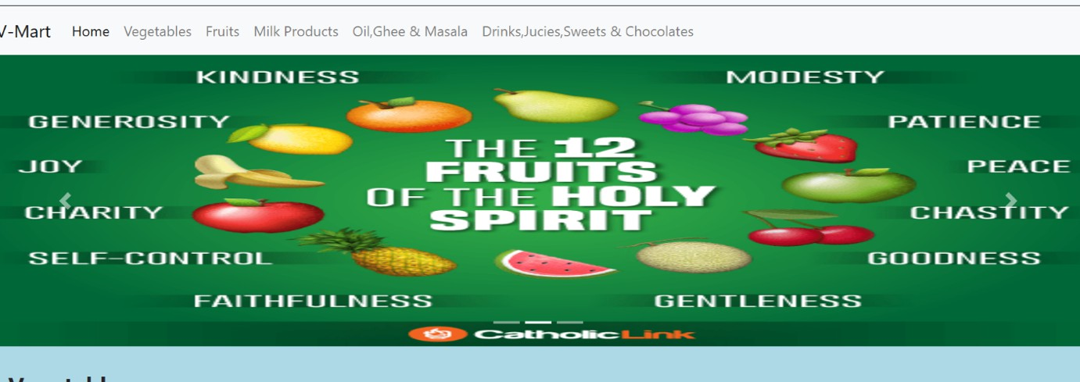

Literature Review:
The rise of online grocery shopping has been a significant trend in recent years, driven by technological advancements, shifting consumer preferences, and the increasing demand for convenience. This literature review aims to provide a comprehensive overview of existing research on online grocery stores, examining various facets such as consumer behavior, business models, technological innovations, challenges, and the impact of online grocery shopping on the traditional retail market.

Consumer Behavior and Preferences
Studies indicate that convenience is the primary motivator for consumers to shop for groceries online. According to a study by Kumar et al. (2020), time-saving, avoiding long queues, and the ability to shop from home are key factors that influence consumer adoption of online grocery shopping. Moreover, Sharma et al. (2019) highlight the increasing preference for online platforms due to factors like personalized recommendations and the availability of a wider variety of products compared to physical stores.

Business Models and Market Trends
The online grocery market has seen a variety of business models, ranging from direct-to- consumer platforms to partnerships with traditional brick-and-mortar

stores. Chong et al. (2020) found that online-only grocery stores like Amazon Fresh and Instacart often offer more competitive pricing and flexible delivery options compared to traditional grocery chains that have expanded into the digital space.

Technological Innovations
Technological innovations have been central to the growth of online grocery stores. Yadav et al. (2021) discuss how artificial intelligence (AI) and machine learning are being used to personalize shopping experiences, predict demand, and optimize supply chains. Additionally, the integration of mobile apps and payment systems has greatly simplified the shopping process, leading to higher customer satisfaction.

System Requirements:

Frontend:
HTML, CSS, JavaScript
UI Design (Figma, Sketch) Responsive (Bootstrap)

Backend:
Languages (Python, PHP, Node.js, Java) Databases (MySQL, PostgreSQL, MongoDB) Server (Apache, Nginx)

Payment Gateway:
Stripe, PayPal, Razorpay

Security:
SSL, 2FA, Encryption

Hardware & Software Requirements Hardware
    - Web Servers – To host the website and handle incoming traffic.

    - Database Servers – For storing and managing product data, customer information, orders, etc
    - Storage – Sufficient storage for product images, videos, and backups.

    - Backup Systems – To ensure data redundancy and protection against data loss.

    - Load Balancers – To distribute traffic efficiently across multiple servers.

    - Security Infrastructure – Hardware firewalls and SSL certificates to protect customer data.
    - Networking Equipment – Routers, switches, and bandwidth to ensure smooth online transactions.
    - Payment Gateway Hardware – For processing payments securely.

Software

- Operating System: Linux (Ubuntu, CentOS) or Windows Server for the server.

- Cross-platform support for client devices (Windows, macOS, iOS, Android).

- Web Server: Apache HTTP Server or Nginx.

- Database: MySQL, PostgreSQL for structured data.

MongoDB for unstructured or dynamic data.

Programming Languages:

Backend: PHP, Python (Django), Ruby, or Node.js. Frontend: HTML, CSS, JavaScript (React.js, Angular).

Payment Gateway Integration:

PayPal, Stripe, and other third-party payment solutions.

Security:

SSL/TLS encryption, two-factor authentication, firewall software, and PCI-DSS compliance for secure transactions.

Short Software Requirements Specification (SRS) for E-Commerce Website
- Introduction Purpose
This document outlines the software requirements for an e-commerce website, focusing on user-friendly shopping, secure transactions, and efficient management.

Overall Description Product Functions
  - User Management: Registration, login, profile management.
  - Product Management: Browse, search, filter products.
  - Shopping Cart: Add/remove items, update quantities.
  - Order Management: Checkout, order tracking.
  - Payment Integration: Support multiple payment methods.
  - Admin Dashboard: Manage products, users, and orders.

Constraints
    - Comply with GDPR and PCI DSS.
    - Support up to 10,000 concurrent users.

Specific Requirements Functional Requirements
- Secure user authentication.
- Product search and filters by category, price, and ratings.
- Smooth checkout with order confirmation.

Non-Functional Requirements
- Load pages within 2 seconds.
- Ensure 99.9% uptime.
- Use SSL for secure data transmission.

External Interfaces
- User-friendly, responsive UI.
- Integrate with payment gateways (e.g., Stripe, PayPal).

System Designs

Architecture
  - Frontend: Built using React or Angular for a responsive and interactive user interface.
  - Backend: Node.js or Django for handling business logic and API integration.

Database:
    - Relational (MySQL/PostgreSQL) for structured data (products, orders, users).
    - NoSQL (MongoDB) for unstructured data (logs, analytics).

  - Hosting: Cloud-based (AWS, Azure) with auto-scaling and load balancing.

Key Components
- User Management
- Authentication via JWT or OAuth.
- Secure password storage using hashing (e.g., bcrypt).

Product Management
- Product catalog stored in the database with indexing for search.
- Search and filter features implemented using Elasticsearch.

Shopping Cart
- Session-based cart for guests.
- Persistent cart for logged-in users using database storage.

Order Management
- Multi-step checkout process.
- Order tracking with status updates.

Payment Gateway
- Integration with Stripe, PayPal, or Razorpay for secure transactions.

Admin Panel
- Dashboard for managing products, orders, and users.
- Analytics visualization using libraries like Chart.js or D3.js.

Deployment
- CI/CD Pipeline: Automate testing and deployment using Jenkins or GitHub Actions.
- Monitoring: Tools like New Relic or Grafana for real-time performance tracking.

Security
- Use HTTPS for secure communication.
- Implement firewalls and regular vulnerability scanning.
- Protect against SQL injection, XSS, and CSRF attacks.

High-Level Diagram
[Client Devices]
|
[Load Balancer]
|
[Application Servers]

|
[Database + Cache]
|
[Payment Gateway, CDN, Search, Shipping APIs]

Modules of System

. User Module: Registration, login, profile management, role-based access.
Product Management: CRUD for products, catalog browsing, search, and filters.
Shopping Cart: Add/remove items, update quantities, save cart.
Order Management: Place orders, track orders, view history, generate invoices.
Payment Integration: Secure payment gateways, refunds, transaction history.
Shipping: Real-time shipping cost, tracking via APIs.
Admin Dashboard: Manage users, products, orders, and view analytics.
Notifications: Email/SMS alerts for orders and updates.

UML Diagrams
Use Case Diagram (Textual Representation)
    - Actors:
      - Customer: The user who shops at the online grocery store.
      - Admin: The person who manages the inventory, orders, and overall store.
      - Payment System: External system to process payments.
    - Use Cases:
      - Browse Products: Customers can view available products.
      - Add to Cart: Customers can add items to their shopping cart.
      - Place Order: After selecting products, customers can place an order.
      - Make Payment: Customers can complete their purchase through a payment system.
      - View Order History: Customers can view past orders.
      - Search Products: Customers can search for specific products.
      - Manage Inventory: Admin can add or remove products from the inventory.
      - Process Orders: Admin can process and dispatch orders.
      - Manage Users: Admin can manage customer accounts.
      - Track Payment: Payment system processes payment and informs the system of status.

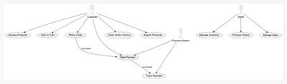









Customer
Payment system

Brown Products
Search products

Add to cart Place order
View order history

includes

Make paymnet
includes

Track payment




Manage users
Manage payment
Process orders

Admin

Implementation

Technology Stack Frontend:
    - Languages: HTML, CSS, JavaScript.
    - Frameworks: React.js, Angular, or Vue.js.

Features:
      - Responsive design for mobile and desktop.
      - User-friendly navigation for browsing and searching products.

Backend:
    - Languages: Node.js, Python (Django/Flask), Java (Spring Boot), or Ruby on Rails.

Features:
      - RESTful APIs for data handling.
      - Business logic for cart, orders, and payments.

Database:
    - Relational Databases: MySQL, PostgreSQL.
    - NoSQL Databases: MongoDB (for flexibility in product catalog).

Features:
      - Data storage for users, products, orders, and transactions.
      - Optimization for search and filtering.
Hosting:
    - Cloud Providers: AWS, Google Cloud, Azure.
    - Services: Load balancers, auto-scaling, CDN (e.g., Cloudflare).

- Key Modules and Their Implementation
- User Management:
  - Features: Registration, login/logout, profile updates.

Implementation:
    - Authentication: Use OAuth 2.0 or JWT.
    - Encryption: Store passwords securely using bcrypt.

Product Management:
  - Features: Add, update, delete products (Admin); search and browse (Customer).

Implementation:
    - Database schema: Store product details, images, and stock.
    - Search: Use Elasticsearch or database indexing for fast queries.

Shopping Cart:
  - Features: Add/remove items, calculate total price.

Implementation:
    - Store cart data in sessions (short-term) or a database (long-term).
    - Apply business logic for discounts and taxes.

Order Management:
  - Features: Order placement, tracking, history.

Implementation:

    - Use order status enums (e.g., Pending, Shipped, Delivered).
    - Send real-time order updates using WebSockets or notifications.

Payment Integration:
  - Features: Secure payment processing, refunds.

Implementation:
    - Integrate payment gateways (e.g., Stripe, PayPal).
    - Ensure PCI DSS compliance for secure transactions.

Shipping:
  - Features: Real-time tracking, shipping cost calculation.

Implementation:
    - Integrate third-party shipping APIs (e.g., FedEx, UPS).

Admin Dashboard:
  - Features: Manage users, view sales reports, monitor activities.

Implementation:
    - Use data visualization libraries (e.g., Chart.js, Recharts).

Sample Code

<!DOCTYPE html>
<html>

<head>
<link rel="stylesheet"
href="https://stackpath.bootstrapcdn.com/bootstrap/4.5.2/css/bootstrap.min.css" integrity="sha384-JcKb8q3iqJ61gNhttps://learning.ccbp.in/frontend-code- playground/new#ExploreVegetablesectionV9KGb8thSsNjpSL0n8PARn9HuZOnIxN 0hoP+VmmDGMN5t9UJ0Z" crossorigin="anonymous" />
<script src="https://code.jquery.com/jquery-3.5.1.slim.min.js" integrity="sha384- DfXdz2htPH0lsSSs5nCTpuj/zy4C+OGpamoFVy38MVBnE+IbbVYUew+OrCXaRkf j" crossorigin="anonymous"></script>
<script src="https://cdn.jsdelivr.net/npm/popper.js@1.16.1/dist/umd/popper.min.js" integrity="sha384- 9/reFTGAW83EW2RDu2S0VKaIzap3H66lZH81PoYlFhbGU+6BZp6G7niu735Sk7l N" crossorigin="anonymous"></script>
<script src="https://stackpath.bootstrapcdn.com/bootstrap/4.5.2/js/bootstrap.min.js" integrity="sha384- B4gt1jrGC7Jh4AgTPSdUtOBvfO8shuf57BaghqFfPlYxofvL8/KUEfYiJOMMV+rV" crossorigin="anonymous"></script>
<script>
function validateLogin() {
// Updated usernames and passwords const validUsers = {
"sagar": "456789", // **Updated password for sagar** "mahitha": "123456789", // **Updated password for mahitha**

"vijaya": "23456789", // **Updated password for vijaya** "pavani": "345678" // **Updated password for pavani**
};

const username = document.getElementById("username").value; const password = document.getElementById("password").value; const errorMessage = document.getElementById("error-message");

if (validUsers[username] && validUsers[username] === password) { alert("Login successful!");
// Hide the login section and directly go to the shopping section document.getElementById("sectionusername").style.display = "none"; document.getElementById("sectionwelcomecontainer").style.display =
"none";
document.getElementById("sectionitems").style.display = "block";
} else {
errorMessage.style.display = "block";
}
}
</script>
<meta charset="UTF-8">
<meta name="viewport" content="width=device-width, initial-scale=1.0">
<title>Grocery Store Login</title>
</head>
<div id="sectionwelcomecontainer">
<div class="welcome-bg-container d-flex flex-column justify-content-center">
<div class="m-container">
<h1> Welcome to V-Mart </h1>
<p> Best quality and price on fruits & vegetables.</p>
<button class="btn btn-primary" onclick="display('sectionusername')"> Get Started </button>
</div>
</div>
</div>
<div id="sectionusername" style="display: block;">
<div class="username d-flex flex-column justify-content-center p-5 m-5">
<div class="main-heading">
<div class="login-container ml-5">
<h2>Login to Grocery Store</h2>
<div class="error-message" id="error-message" style="display: none;">Invalid username or password</div>
<input type="text" id="username" class="input-field" placeholder="Enter username">
<input type="password" id="password" class="input-field" placeholder="Enter password">

<button class="login-btn" onclick="validateLogin()">Login</button>
</div>
<p class="paragraph">If Account Is Not There Create Here </p>
<button class="btn btn-primary" onclick="display('sectionaccountcraetion')"> Create Your Account </button>
</div>
</div>
</div>
<div id="sectionaccountcraetion">
<div class="account-container d-flex flex-column justify-content-center">
<div class="account-bg-container">
<label for="fname"> First Name : </label>
<input id="fname" type="text"> <br> <br>
<label for="fname"> Last Name : </label>
<input id="fname" type="text"> <br> <br>
<label for="fname"> Gender : </label>
<input id="fname" type="text"> <br> <br> Date of Birth : <input type="date"> <br> <br>
<label for="fname"> Address : </label>
<input id="fname" type="text"> <br> <br>
<button class="btn btn-primary" onclick="display('sectionitems')"> Start Shopping </button>
</div>
</div>
</div>
<div id="sectionitems" style="display: none;">
<div class="menu-container">
<nav class="navbar navbar-expand-lg navbar-light bg-light">
<a class="navbar-brand" href="#">V-Mart</a>
<button class="navbar-toggler" type="button" data-toggle="collapse" data- target="#navbarNavAltMarkup" aria-controls="navbarNavAltMarkup" aria- expanded="false" aria-label="Toggle navigation">
<span class="navbar-toggler-icon"></span>
</button>
<div class="collapse navbar-collapse" id="navbarNavAltMarkup">
<div class="navbar-nav">
<a class="nav-link active" href="#">Home <span class="sr- only">(current)</span></a>
<a class="nav-link" href="#vegetablessection">Vegetables</a>
<a class="nav-link" href="#fruitssection">Fruits</a>
<a class="nav-link" href="#milksection">Milk Products</a>
<a class="nav-link" href="#oilsection">Oil,Ghee & Masala</a>
<a class="nav-link" href="#drinkssection">Drinks,Jucies,Sweets & Chocolates</a>
</div>

</div>
</nav>
<div id="carouselExampleIndicators" class="carousel slide" data- ride="carousel">
<ol class="carousel-indicators">
<li data-target="#carouselExampleIndicators" data-slide-to="0" class="active"></li>
<li data-target="#carouselExampleIndicators" data-slide-to="1"></li>
<li data-target="#carouselExampleIndicators" data-slide-to="2"></li>
</ol>
<div class="carousel-inner">
<div class="carousel-item active">
<img src="https://wallpapercave.com/wp/wp3104916.jpg" class="d-block w-100 image-height" alt="..." />
</div>
<div class="carousel-item">
<img src="https://catholic-link.org/wp- content/uploads/2016/05/tumblr_o72kakTGJi1uggvbco1_1280.png" class="d-block w-100 image-height" alt="..." />
</div>
<div class="carousel-item">
<img src="https://th.bing.com/th/id/OIP.M0yXXJzA_GhBsMW3rApx9gHaE8?rs=1&pid=I mgDetMain" class="d-block w-100 image-height" alt="..." />
</div>
</div>
<a class="carousel-control-prev" href="#carouselExampleIndicators" role="button" data-slide="prev">
<span class="carousel-control-prev-icon" aria-hidden="true"></span>
<span class="sr-only">Previous</span>
</a>
<a class="carousel-control-next" href="#carouselExampleIndicators" role="button" data-slide="next">
<span class="carousel-control-next-icon" aria-hidden="true"></span>
<span class="sr-only">Next</span>
</a>
</div>

<div id="vegetablessection">
<div>
<h1 class="sub-heading"> Vegetables </h1>
</div>

<div class="d-flex flex-row">

<div class="view-container shadow p-3 mt-5 mb-3">

<img src="https://im.indiatimes.in/content/2023/Jun/tomato_649e99ca42014.jpg" class="menu-item-image w-100" onclick="display('sectiontomato')" />
<h1 class="view-title">Tomato</h1>

</div>

<div class="view-container shadow p-3 mt-5 mb-3">
<img src="https://gwpriceltd.co.uk/wp- content/uploads/2020/04/GWPrice-Onions-Red-min.jpg" class="menu-item-image w- 100" onclick="display('sectiononion')" />
<h1 class="view-title">Onion</h1>

</div>

<div class="view-container shadow p-3 mt-5 mb-3">
<img src="https://th.bing.com/th/id/R.aa0a7e5f75178906f0d2741f13543af0?rik=q4vuMh3 PW8lGJg&riu=http%3a%2f%2fwww.valleyspuds.com%2fwp- content%2fuploads%2fValley-Spuds-Pile-of-White- Potatoes.jpg&ehk=ZQ5wZKG9ZoqCX22zdRT6MQaW6zeZyVUIQUbCWIpJ7kU% 3d&risl=&pid=ImgRaw&r=0" class="menu-item-image w-100" onclick="display('sectionpotato')" />
<h1 class="view-title">Potato</h1>

</div>
</div>

<div class="d-flex flex-row ">
<div class="view-container shadow p-3 mt-5 mb-3">
<img src="https://th.bing.com/th/id/R.09992bd09dcb791b0c69f1276591a970?rik=4mOqWr GhQXIJgQ&riu=http%3a%2f%2fwww.theayurveda.org%2fwp- content%2fuploads%2f2015%2f09%2fCarrot- fruits.jpg&ehk=VxTGCN5rKfbNmckesr1TgZwTJvbHrtJb%2byGuylQI7gc%3d&risl
=&pid=ImgRaw&r=0" class="menu-item-image w-100" onclick="display('sectioncarrot')" />
<h1 class="view-title">Orange Carrot</h1>

</div>

<div class="view-container shadow p-3 mt-5 mb-3">

<img src="https://img.onmanorama.com/content/dam/mm/en/food/features/images/2021/4/ 7/chillies.jpg" class="menu-item-image w-100" onclick="display('sectionchilli')" />
<h1 class="view-title">Green Chilli</h1>

</div>

<div class="view-container shadow p-3 mt-5 mb-3">
<img src="https://www.organicfacts.net/wp- content/uploads/2013/05/Lemon3.jpg" class="menu-item-image w-100" onclick="display('sectionlemon')" />
<h1 class="view-title">Lemon</h1>

</div>
</div>
<div class="d-flex flex-row">
<div class="view-container shadow p-3 mt-5 mb-3">
<img src="https://th.bing.com/th/id/OIP.tKQ3N9tqqJQvq7JaiJ8O9QHaEd?rs=1&pid=Img DetMain" class="menu-item-image w-100" onclick="display('sectioncucumber')" />
<h1 class="view-title">English Cucumber </h1>

</div>

<div class="view-container shadow p-3 mt-5 mb-3">
<img src="https://5.imimg.com/data5/EJ/RI/RK/SELLER- 54986354/fresh-lady-finger-1000x1000.jpg" class="menu-item-image w-100" onclick="display('sectionfinger')" />
<h1 class="view-title">Lady Finger </h1>

</div>

<div class="view-container shadow p-3 mt-5 mb-3">
<img src="https://seasonharvest.com/wp- content/uploads/2020/11/Coriander.jpg" class="menu-item-image w-100" onclick="display('sectioncoriander')" />
<h1 class="view-title">Coriander </h1>

</div>
</div>
<div class="d-flex flex-row">
<div class="view-container shadow p-3 mt-5 mb-3">
<img src="https://thefarmersjournal.com/wp- content/uploads/2023/05/Comprehensive-Guide-to-Ginger-Farming-Cultivation-

Fertilizer-Schedule-and-Postharvest-Handling.jpg" class="menu-item-image w-100"
.onclick="display('sectionginger')" />
<h1 class="view-title"> Ginger </h1>

</div>

<div class="view-container shadow p-3 mt-5 mb-3">
<img src="https://th.bing.com/th/id/OIP.H60uFPaoW5- KV4xyhhvRDgHaE1?rs=1&pid=ImgDetMain" class="menu-item-image w-100" onclick="display('sectioncapsicum')" />
<h1 class="view-title"> Capsicum </h1>

</div>

<div class="view-container shadow p-3 mt-5 mb-3">
<img src="https://www.thespruceeats.com/thmb/2ffv5aUIF16x7ih3fyMgkBRiyks=/5600x3 761/filters:no_upscale():max_bytes(150000):strip_icc()/GettyImages-641147548- f685bc0c51d649cbb1e14469745d5c9e.jpg" class="menu-item-image w-100" onclick="display('sectioncauliflower')" />
<h1 class="view-title"> Cauliflower </h1>

</div>
</div>
<div class="d-flex flex-row">
<div class="view-container shadow p-3 mt-5 mb-3">
<img src="https://saveourgreen.org/allpost/wp- content/uploads/2017/07/garlic-picture.jpg" class="menu-item-image w-100" onclick="display('sectiongarlic')" />
<h1 class="view-title"> Garlic </h1>

</div>

<div class="view-container shadow p-3 mt-5 mb-3">
<img src="https://howardbrownfarms.com/wp- content/uploads/2020/07/green-beans.jpg" class="menu-item-image w-100" onclick="display('sectionbeans')" />
<h1 class="view-title"> Beans </h1>

</div>
</div>
</div>
<div id="fruitssection">
<div>
<h1 class="sub-heading"> Fruits </h1>

</div>
<div class="d-flex flex-row">
<div class="view-container shadow p-3 mt-5 mb-3">
<img src="https://healthjade.com/wp-content/uploads/2017/09/kiwi- fruit.jpg" class="menu-item-image w-100" onclick="display('sectionkiwi')" />
<h1 class="view-title"> Kiwi </h1>

</div>

<div class="view-container shadow p-3 mt-5 mb-3">
<img src="https://th.bing.com/th/id/R.370a1a27cf44d97024b4b0ac6e836257?rik=upZWK Ku48HQUaQ&riu=http%3a%2f%2fclipart-library.com%2fimages_k%2forange- transparent-background%2forange-transparent-background- 1.jpg&ehk=8LRfSYDUOoxbhy1g%2b3zcZaXhpmgplsMbhslNpCdgG7Y%3d&risl= &pid=ImgRaw&r=0" class="menu-item-image w-100" onclick="display('sectionorange')" />
<h1 class="view-title"> Orange </h1>

</div>

<div class="view-container shadow p-3 mt-5 mb-3">
<img src="https://th.bing.com/th/id/OIP.iDxI1s15TCL3xYo4yJHf0wHaFj?rs=1&pid=Img DetMain" class="menu-item-image w-100" onclick="display('sectiongrapes')" />
<h1 class="view-title"> Grapes </h1>

</div>
</div>
<div class="d-flex flex-row">
<div class="view-container shadow p-3 mt-5 mb-3">
<img src="https://healthjade.com/wp- content/uploads/2017/10/blackberry.jpg" class="menu-item-image w-100" onclick="display('sectionblackberry')" />
<h1 class="view-title"> Blackberry </h1>

</div>

<div class="view-container shadow p-3 mt-5 mb-3">
<img src="https://th.bing.com/th/id/R.594005a4c3d0d0f993dd90f53ccd3c53?rik=pHj7LCY I8hBuqA&riu=http%3a%2f%2fwww.foodrepublic.com%2fwp- content%2fuploads%2f2013%2f09%2fglamorous-assorted-apples-pictures-hd- wallpaper-hd- pictures.jpg&ehk=JtKQrsZjweWW8E9AsLD8IepGx1CuGZKO2dgA%2byfMlN8%3

d&risl=&pid=ImgRaw&r=0" class="menu-item-image w-100" onclick="display('sectionapple')" />
<h1 class="view-title"> Apples </h1>

</div>

<div class="view-container shadow p-3 mt-5 mb-3">
<img src="https://www.vietnamonline.com/media/uploads/froala_editor/images/VNO- Guava1.jpg" class="menu-item-image w-100" onclick="display('sectionguava')" />
<h1 class="view-title"> Guava </h1>

</div>
</div>
<div class="d-flex flex-row">
<div class="view-container shadow p-3 mt-5 mb-3">
<img src="https://th.bing.com/th/id/OIP.fq6VMNnUgGmrWCmjrE6WsQHaGG?rs=1&pid
=ImgDetMain" class="menu-item-image w-100" onclick="display('sectionbanana')"
/>
<h1 class="view-title"> Banana </h1>

</div>

<div class="view-container shadow p-3 mt-5 mb-3">
<img src="https://cdn.britannica.com/96/201196-050-C0441508/Batch- pomegranate-fruits.jpg" class="menu-item-image w-100" onclick="display('sectionpomegranate')" />
<h1 class="view-title"> Pomegranate </h1>

</div>

<div class="view-container shadow p-3 mt-5 mb-3">
<img src="https://cdn.mos.cms.futurecdn.net/XenViG9cC4EdGupeibtKa5.jpg" class="menu-item-image w-100" onclick="display('sectionwatermelon')" />
<h1 class="view-title"> Watermelon </h1>

</div>
</div>
<div class="d-flex flex-row">
<div class="view-container shadow p-3 mt-5 mb-3">
<img src="https://i.ytimg.com/vi/xHwSWzCmKPw/maxresdefault.jpg" class="menu-item-image w-100" onclick="display('sectionpineapple')" />
<h1 class="view-title"> Pineapple </h1>

</div>

<div class="view-container shadow p-3 mt-5 mb-3">
<img src="https://th.bing.com/th/id/OIP.x_3a1i4wXwlmUDOh4S4G0gHaE8?rs=1&pid=Im gDetMain" class="menu-item-image w-100" onclick="display('sectiondragonfruit')"
/>
<h1 class="view-title"> Dragon Fruit </h1>

</div>
</div>
</div>
</div>

<div id="milksection">
<div class="menu-container">
<div>
<h1 class="sub-heading"> Milk Products </h1>
</div>
<div class="d-flex flex-row">
<div class="view-container shadow p-3 mt-5 mb-3">
<img src="https://www.bigbasket.com/media/uploads/p/xl/40214909_2- visakha-milk-pasteurised-full-cream-milk.jpg" class="menu-item-image w-100" onclick="display('sectionvcmilk')" />
<h1 class="view-title"> Visakha Dairy Full Cream Milk </h1>

</div>

<div class="view-container shadow p-3 mt-5 mb-3">
<img src="https://m.media-amazon.com/images/I/61bK9D+r- 5L._SL1168_.jpg" class="menu-item-image w-100" onclick="display('sectionvtmilk')" />
<h1 class="view-title"> Visakha Dairy Toned Fresh Milk </h1>

</div>

<div class="view-container shadow p-3 mt-5 mb-3">
<img src="https://freshclub.co.in/cdn/shop/products/815V9EawbJL._SL1500.png?v=16559 86659&width=713" class="menu-item-image w-100" onclick="display('sectionhtmilk')" />
<h1 class="view-title"> Heritage Dairy Toned Fresh Milk </h1>

</div>
</div>
<div class="d-flex flex-row">
<div class="view-container shadow p-3 mt-5 mb-3">
<img src="https://th.bing.com/th/id/OIP.XwM- VTM975BF9GLldvQcqgHaHa?rs=1&pid=ImgDetMain" class="menu-item-image w- 100" onclick="display('sectionhcmilk')" />
<h1 class="view-title"> Heritage Dairy Fill Cream Fresh Milk </h1>

</div>

<div class="view-container shadow p-3 mt-5 mb-3">
<img src="https://th.bing.com/th/id/OIP.dZAqFxHWuIC2BBJ_MvqfrAHaD3?rs=1&pid=I mgDetMain" class="menu-item-image w-100" onclick="display('sectionhcurd')" />
<h1 class="view-title"> Heritage curd </h1>

</div>

<div class="view-container shadow p-3 mt-5 mb-3">
<img src="https://www.bigbasket.com/media/uploads/p/xl/40199928_1- sangam-gold-pasteurised-full-cream-milk.jpg" class="menu-item-image w-100" onclick="display('sectionsmilk')" />
<h1 class="view-title"> Sangam Dairy Fill Cream Fresh Milk </h1>

</div>
</div>
</div>
<div id="oilsection" class="menu-container">
<div>
<h1 class="sub-heading"> Oil,Ghee & Masala </h1>
</div>
<div class="d-flex flex-row">
<div class="view-container shadow p-3 mt-5 mb-3">
<img src="https://cdn.grabon.in/gograbon/indulge/wp- content/uploads/2023/07/Saffola-Honey.jpg" class="menu-item-image w-100" onclick="display('sectionsoil')" />
<h1 class="view-title"> Saffola Oil </h1>

</div>

<div class="view-container shadow p-3 mt-5 mb-3">
<img src="https://cdn.grabon.in/gograbon/indulge/wp- content/uploads/2023/09/Fortune.png" class="menu-item-image w-100" onclick="display('sectionfoil')" />

<h1 class="view-title"> Fortune Oil </h1>

</div>

<div class="view-container shadow p-3 mt-5 mb-3">
<img src="https://m.media-
amazon.com/images/I/81OYU4frpbL._SL1500_.jpg" class="menu-item-image w- 100" onclick="display('sectionsunoil')" />
<h1 class="view-title"> Sunflower Oil </h1>

</div>
</div>
<div class="d-flex flex-row">
<div class="view-container shadow p-3 mt-5 mb-3">
<img src="https://m.media-amazon.com/images/S/aplus-media-library- service-media/9a03f20f-769f-470c-90bc-
d3216c1cde27. CR0,0,970,600_PT0_SX970_V1 .png" class="menu-item-image w-100" onclick="display('sectionolveoil')" />
<h1 class="view-title"> Olive Oil </h1>

</div>

<div class="view-container shadow p-3 mt-5 mb-3">
<img src="https://m.media-
amazon.com/images/I/71EctccWdaL._SL1500_.jpg" class="menu-item-image w-100" onclick="display('sectiongoil')" />
<h1 class="view-title"> Gold Drop Oil </h1>

</div>

<div class="view-container shadow p-3 mt-5 mb-3">
<img src="https://m.media-amazon.com/images/S/aplus-media-library- service-media/0c213747-6448-4440-8709-
770e519551c5. CR0,0,970,600_PT0_SX970_V1 .png" class="menu-item-image w-100" onclick="display('sectiongroundnutoil')" />
<h1 class="view-title"> Groundnut Oil </h1>

</div>
</div>
<div class="d-flex flex-row">
<div class="view-container shadow p-3 mt-5 mb-3">
<img src="https://www.sabrinifoods.com/wp-content/uploads/2019/08/2- Buffalo-Ghee.jpg" class="menu-item-image w-100" onclick="display('sectiongrbghee')" />
<h1 class="view-title"> GRB Buffalo Ghee </h1>

</div>

<div class="view-container shadow p-3 mt-5 mb-3">
<img src="https://m.media-
amazon.com/images/I/619wJVmYJrL._SL1280_.jpg" class="menu-item-image w- 100" onclick="display('sectiondghee')" />
<h1 class="view-title"> Durga Buffalo Ghee </h1>

</div>

<div class="view-container shadow p-3 mt-5 mb-3">
<img src="https://www.bigbasket.com/media/uploads/p/l/257872_3- visakha-dairy-pure-ghee.jpg" class="menu-item-image w-100" onclick="display('sectionvghee')" />
<h1 class="view-title"> Visakha Buffalo Ghee </h1>

</div>
</div>
<div class="d-flex flex-row">
<div class="view-container shadow p-3 mt-5 mb-3">
<img src="https://onlinehalalfood.com/wp- content/uploads/2024/04/535_Ghee-Amul-pure-ghee.jpg" class="menu-item-image w- 100" onclick="display('sectionaghee')" />
<h1 class="view-title"> Amul Buffalo Ghee </h1>

</div>

<div class="view-container shadow p-3 mt-5 mb-3">
<img src="https://cdn.pixelbin.io/v2/jiomart-partner/jmp- pr/wrkr/products/pictures/item/free/original/3VI4aid3W5- 0000000004916417581.jpg.jpeg" class="menu-item-image w-100" onclick="display('sectionkghee')" />
<h1 class="view-title"> Kapiva Buffalo Ghee </h1>

</div>

<div class="view-container shadow p-3 mt-5 mb-3">
<img src="https://m.media-
amazon.com/images/I/71m7LN1AusL._SL1500_.jpg" class="menu-item-image w- 100" onclick="display('sectionhghee')" />
<h1 class="view-title"> Heritage Buffalo Ghee </h1>

</div>
</div>

<div class="d-flex flex-row">
<div class="view-container shadow p-3 mt-5 mb-3">
<img src="https://www.bigbasket.com/media/uploads/p/l/40323679_1- india-gate-classic-hyderabadi-biryani-masala.jpg" class="menu-item-image w-100" onclick="display('sectionimasala')" />
<h1 class="view-title"> India Gate Classic Hydrabadi Biryani Masala
</h1>

</div>

<div class="view-container shadow p-3 mt-5 mb-3">
<img src="https://cdn.shopify.com/s/files/1/0549/7208/8504/products/Everest_Chicken_Ma sala_100g-Everest-Spices_800x.png?v=1620501323" class="menu-item-image w- 100" onclick="display('sectionemasala')" />
<h1 class="view-title"> Everest Chicken Masala </h1>

</div>

<div class="view-container shadow p-3 mt-5 mb-3">
<img src="https://th.bing.com/th/id/OIP.b2QiWXxOphmFwkqcaWtUOQHaHa?rs=1&pid= ImgDetMain" class="menu-item-image w-100" onclick="display('sectionmtrchilli')"
/>
<h1 class="view-title"> MTR Chilli Powdwe (Kharam) </h1>

</div>
</div>
<div class="d-flex flex-row">
<div class="view-container shadow p-3 mt-5 mb-3">
<img src="https://rukminim2.flixcart.com/image/832/832/xif0q/spice- masala/6/b/d/-original-imagtbd9q8uysftg.jpeg?q=70" class="menu-item-image w- 100" onclick="display('sectionaturmeric')" />
<h1 class="view-title"> Aashirvaad Haldi/Turmeric Powder </h1>

</div>

<div class="view-container shadow p-3 mt-5 mb-3">
<img src="https://www.bigbasket.com/media/uploads/p/l/100270856_7- eastern-masala-biryani.jpg" class="menu-item-image w-100" onclick="display('sectioneasternmasala')" />
<h1 class="view-title"> Eastern Biryani Masala </h1>

</div>

<div class="view-container shadow p-3 mt-5 mb-3">
<img src="https://www.spencers.in/media/catalog/product/1/0/1012424.jpg" class="menu- item-image w-100" onclick="display('sectionashirvaadchillipowder')" />
<h1 class="view-title"> Aashirvaad Chilli Powder </h1>

</div>
</div>
<div class="d-flex flex-row">
<div class="view-container shadow p-3 mt-5 mb-3">
<img src="https://i5.walmartimages.com/asr/29c416da-b7d9-448b-b85f- c0ccf5b2a88e_1.183e8f6c9edc7279f2acebe9fc39a81e.jpeg?odnWidth=1000&odnHei ght=1000&odnBg=ffffff" class="menu-item-image w-100" onclick="display('sectionstmasala')" />
<h1 class="view-title"> Shan Tandoori Masala </h1>

</div>

<div class="view-container shadow p-3 mt-5 mb-3">
<img src="https://orikaflavours.com/cdn/shop/files/blackpepper_2.png?v=1715149037&wi dth={width}" class="menu-item-image w-100" onclick="display('sectionopmasala')"
/>
<h1 class="view-title"> Orika Malbar Black Pepper Powder </h1>

</div>

<div class="view-container shadow p-3 mt-5 mb-3">
<img src="https://m.media-
amazon.com/images/I/61t1yNKMeoL._SL1100_.jpg" class="menu-item-image w- 100" onclick="display('sectionjeera')" />
<h1 class="view-title"> Catch Jeera Powder </h1>

</div>
</div>
</div>

<div id="drinkssection" class="menu-container">
<div>
<h1 class="sub-heading"> Drinks,Jucies,Sweets & Chocolates
</h1>
</div>
<div class="d-flex flex-row">
<div class="view-container shadow p-3 mt-5 mb-3">

<img src="https://m.media-
amazon.com/images/I/51xhpEQimiL._SL1500_.jpg" class="menu-item-image w-100" onclick="display('sectiontudrink')" />
<h1 class="view-title"> Thums Up </h1>

</div>

<div class="view-container shadow p-3 mt-5 mb-3">
<img src="https://facts.net/wp-content/uploads/2023/09/20-facts-about- sprite-1695406210.jpg" class="menu-item-image w-100" onclick="display('sectionspdrink')" />
<h1 class="view-title"> Sprite </h1>

</div>

<div class="view-container shadow p-3 mt-5 mb-3">
<img src="https://i5.walmartimages.com/asr/e3e510eb-3379-4ce5-a8e2- 31f45ed5a47e.c99ca9cb61a8a839c23892605149d63b.jpeg" class="menu-item-image w-100" onclick="display('sectioncdrink')" />
<h1 class="view-title"> Coke </h1>

</div>
</div>
<div class="d-flex flex-row">
<div class="view-container shadow p-3 mt-5 mb-3">
<img src="https://www.spencers.in/media/catalog/product/1/4/1414987_1.jpg" class="menu-item-image w-100" onclick="display('sectionpdrink')" />
<h1 class="view-title"> Paper boat Zero Lemon LIme </h1>

</div>

<div class="view-container shadow p-3 mt-5 mb-3">
<img src="https://www.hccb.in/images/limca-blog.jpg" class="menu- item-image w-100" onclick="display('sectionldrink')" />
<h1 class="view-title"> Limca </h1>

</div>

<div class="view-container shadow p-3 mt-5 mb-3">
<img src="https://imgproxy.newswav.com/1000x0,q50=/https://www.insidehook.com/wp- content/uploads/2023/05/nonalcoholicbeers_1500x1000-header.jpg" class="menu- item-image w-100" onclick="display('sectionjgrink')" />
<h1 class="view-title"> Jimmy's Malt Non-Alcoholic Beer </h1>

</div>
</div>
<div class="d-flex flex-row">
<div class="view-container shadow p-3 mt-5 mb-3">
<img src="https://mlq.co.nz/wp-content/uploads/2022/01/145845-Fanta- Orange-330ml-Can-595.jpg" class="menu-item-image w-100" onclick="display('sectionfdrink')" />
<h1 class="view-title"> Fanta </h1>

</div>

<div class="view-container shadow p-3 mt-5 mb-3">
<img src="https://i5.walmartimages.com/asr/69f93370-7023-4bfb-a0fc- e5cc931e49b6_1.7d37e56bd03cee7eee8a41395de92e30.jpeg" class="menu-item- image w-100" onclick="display('sectionpepsidrink')" />
<h1 class="view-title"> Pepsi </h1>

</div>

<div class="view-container shadow p-3 mt-5 mb-3">
<img src="https://i.pinimg.com/originals/ff/ca/3f/ffca3f9a1c7f8f9599f02d9996691faa.jpg" class="menu-item-image w-100" onclick="display('sectionjgadrink')" />
<h1 class="view-title"> Jamesion Ginger Ale </h1>

</div>
</div>
<div class="d-flex flex-row">
<div class="view-container shadow p-3 mt-5 mb-3">
<img src="https://i5.walmartimages.com/asr/7a250be5-558d-462d-b1b0- 8ba932fe01f3.52dae0372e6d761a9b0f8c928c3f2371.jpeg" class="menu-item-image w-100" onclick="display('sectionrbdrink')" />
<h1 class="view-title"> Red Bull Energy Drink </h1>

</div>

<div class="view-container shadow p-3 mt-5 mb-3">
<img src="https://m.media-
amazon.com/images/I/712RJbwtyTL._SL1500_.jpg" class="menu-item-image w-100" onclick="display('sectiongddrink')" />
<h1 class="view-title"> Glucon-D </h1>

</div>

<div class="view-container shadow p-3 mt-5 mb-3">
<img src="https://th.bing.com/th/id/OIP.nKyczKBioxenxVgh9GjS4QHaD0?rs=1&pid=Img DetMain" class="menu-item-image w-100" onclick="display('sectioncdm')" />
<h1 class="view-title"> Cadbury Dairy Milk </h1>

</div>
</div>
<div class="d-flex flex-row">
<div class="view-container shadow p-3 mt-5 mb-3">
<img src="https://rukminim1.flixcart.com/image/832/832/xif0q/chocolate/w/g/e/325-kisses- milk-chocolate-new-xl-pack-1-hershey-s-original-imagh5bjey4jgrjt.jpeg?q=70" class="menu-item-image w-100" onclick="display('sectionhcmkiss')" />
<h1 class="view-title"> Hershey's Kisses Milk Chocolate Pack </h1>

</div>

<div class="view-container shadow p-3 mt-5 mb-3">
<img src="https://cdn.zeptonow.com/production/tr:w-600,ar-1100- 1100,pr-true,f-auto,q-80/cms/product_variant/ea977d97-15d2-4612-b4d8- fb954ff65533.jpeg" class="menu-item-image w-100" onclick="display('sectioncdmbites')" />
<h1 class="view-title"> Cadbury Dairy Milk Bites Assorted Chocolate
Pack </h1>

</div>

<div class="view-container shadow p-3 mt-5 mb-3">
<img src="https://shop.hersheys.com/dw/image/v2/BCVS_PRD/on/demandware.static/-
/Sites-master-us/default/dwd4db61eb/images/hi- res/034000952281_1.jpg?sw=1500&sh=1500&sm=fit" class="menu-item-image w- 100" onclick="display('sectionhcmkisstruffle')" />
<h1 class="view-title"> Hershey's Kisses Choco Truffle Assorted Chocolate Pack </h1>

</div>
</div>
<div class="d-flex flex-row">
<div class="view-container shadow p-3 mt-5 mb-3">
<img src="https://i5.walmartimages.com/asr/44385c58-dfd5-4f66-8219- 3c604eaa0fdd_1.c5099207f0af80887b80e7b90ff115d9.jpeg" class="menu-item- image w-100" onclick="display('sectionsnickers')" />
<h1 class="view-title"> Snickers </h1>

</div>

<div class="view-container shadow p-3 mt-5 mb-3">
<img src="https://5.imimg.com/data5/SELLER/Default/2023/2/FI/NY/DN/144328445/cadb urys-fuse-1000x1000.jpg" class="menu-item-image w-100" onclick="display('sectionfuse')" />
<h1 class="view-title"> Cadbury Fuse </h1>

</div>

<div class="view-container shadow p-3 mt-5 mb-3">
<img src="https://th.bing.com/th/id/OIP.vqMU8yHrO0x-
_ZLZF3oBQAHaEg?rs=1&pid=ImgDetMain" class="menu-item-image w-100" onclick="display('sectionjoy')" />
<h1 class="view-title"> Kinder Joy </h1>

</div>
</div>
<div class="d-flex flex-row">
<div class="view-container shadow p-3 mt-5 mb-3">
<img src="https://bisarga.com/wp-content/uploads/2021/06/Nestle- Munch-Chocolate-Bar-202g-Pouch-100.jpg" class="menu-item-image w-100" onclick="display('sectionmunch')" />
<h1 class="view-title"> Nestle Munch Coated Cruchy Wafer Chocolate
</h1>

</div>

<div class="view-container shadow p-3 mt-5 mb-3">
<img src="https://www.nestle.co.uk/sites/g/files/pydnoa461/files/kitkat- brandpage_0.jpg" class="menu-item-image w-100" onclick="display('sectionkitkat')"
/>
<h1 class="view-title"> Kitkat </h1>

</div>

<div class="view-container shadow p-3 mt-5 mb-3">
<img src="https://m.media-
amazon.com/images/I/61NUepJpj3L._SL1500_.jpg" class="menu-item-image w-100" onclick="display('sectionfivestar')" />
<h1 class="view-title"> Cadbury 5 Star </h1>

</div>

</div>
<div class="d-flex flex-row">
<div class="view-container shadow p-3 mt-5 mb-3">
<img src="https://m.media-
amazon.com/images/I/71ErF2P7ffL._SL1500_.jpg" class="menu-item-image w-100" onclick="display('sectionpark')" />
<h1 class="view-title"> Cadbury Park </h1>

</div>

<div class="view-container shadow p-3 mt-5 mb-3">
<img src="https://images-na.ssl-images- amazon.com/images/I/71JHm1clQvL._SL1500_.jpg" class="menu-item-image w- 100" onclick="display('sectiongems')" />
<h1 class="view-title"> Cadbury Gems </h1>

</div>

<div class="view-container shadow p-3 mt-5 mb-3">
<img src="https://assets.myntassets.com/h_200,w_200,c_fill,g_auto/h_1440,q_100,w_1080
/v1/assets/images/24389364/2023/8/8/4d5a5de1-2278-4011-9bed- 81c10b2f02381691481407855SapphireHazelfillsBhaiBhabhiRakhi1.jpg" class="menu-item-image w-100" onclick="display('sectiongift')" />
<h1 class="view-title"> Sapphire Hazelfills Chocolate Gift Pack </h1>
</div>
</div>
</div>
</div>

<div class="container">
<div class="row">
<div class="col-12 text-center">
<div class="footer-section">
<h1 class="footer-section-mail-id">V-Mart@Grocery.com</h1>
<p class="footer-section-address">
123 Ayur Vigyan Nagar, Guntur, India.
</p>
</div>
</div>
</div>
</div>
</div>

<div id="sectiontomato">
<div class="detailed-view-bg-container mt-5">

<img src="https://www.feedipedia.org/sites/default/files/images/tomato_fruits.jpg" class="details-image-contqainer" />

<div class="detailed-view-description-container ml-5 mr-5 p-5">
<h1 class="detailed-view-heading mt-5"> Desi Tomato</h1>
<p class="detailed-view-paragraph m-0"> Free Coriander on above 149 Rupees</p>
<p> 500g</p>
<p> 14 rupees <span>
<p class="detailed-view-paragraph"> 22% OFF</p>
</span></p>
</div>

<button class="btn btn-primary" onclick="display('sectionitems')"> Back</button>

<button class="btn btn-primary" onclick="display('sectionpayment')"> Buy Now</button>
</div>

</div>

<div id="sectiononion">
<div class="detailed-view-bg-container mt-5">

<img src="https://th.bing.com/th/id/R.e6a654467ba0c2c7ee889e2f7285d6d4?rik=otgDorY5 nXo33g&riu=http%3a%2f%2fjustfunfacts.com%2fwp- content%2fuploads%2f2019%2f03%2fonions.jpg&ehk=rVYqPM7t2pTwfq6XsRQX5 JP1oUBYNlPBTjzKlLJ6Xtg%3d&risl=&pid=ImgRaw&r=0&sres=1&sresct=1" class="details-image-contqainer" />

<div class="detailed-view-description-container ml-5 mr-5 p-5">
<h1 class="detailed-view-heading mt-5"> Onion</h1>

<p class="detailed-view-paragraph m-0"> Free Coriander on above 149 Rupees</p>
<p> 500g</p>
<p> 40 rupees <span>
<p class="detailed-view-paragraph"> 22% OFF</p>
</span></p>
</div>

<button class="btn btn-primary" onclick="display('sectionitems')"> Back</button>

<button class="btn btn-primary" onclick="display('sectionpayment')"> Buy Now</button>
</div>
</div>

<div id="sectionpotato">
<div class="detailed-view-bg-container mt-5">

<img src="https://cdn.morningchores.com/wp-content/uploads/2016/10/new- potato.jpg" class="details-image-contqainer" />

<div class="detailed-view-description-container ml-5 mr-5 p-5">
<h1 class="detailed-view-heading mt-5"> Potato </h1>
<p class="detailed-view-paragraph m-0"> Free Coriander on above 149 Rupees</p>
<p> 500g</p>
<p> 28 rupees <span>
<p class="detailed-view-paragraph"> 22% OFF</p>
</span></p>
</div>

<button class="btn btn-primary" onclick="display('sectionitems')"> Back</button>

<button class="btn btn-primary" onclick="display('sectionpayment')"> Buy Now</button>
</div>
</div>

<div id="sectioncarrot">
<div class="detailed-view-bg-container mt-5">

<img src="https://www.theayurveda.org/wp-content/uploads/2015/09/Carrot- fruits.jpg" class="details-image-contqainer" />

<div class="detailed-view-description-container ml-5 mr-5 p-5">
<h1 class="detailed-view-heading mt-5"> Carrot </h1>
<p class="detailed-view-paragraph m-0"> Free Coriander on above 149 Rupees</p>
<p> 500g</p>
<p> 30 rupees <span>
<p class="detailed-view-paragraph"> 22% OFF</p>
</span></p>
</div>

<button class="btn btn-primary" onclick="display('sectionitems')"> Back</button>

<button class="btn btn-primary" onclick="display('sectionpayment')"> Buy Now</button>
</div>
</div>

<div id="sectionchilli">
<div class="detailed-view-bg-container mt-5">

<img src="https://img.onmanorama.com/content/dam/mm/en/food/features/images/2021/4/ 7/chillies.jpg" class="details-image-contqainer" />

<div class="detailed-view-description-container ml-5 mr-5 p-5">
<h1 class="detailed-view-heading mt-5"> Chilli </h1>
<p class="detailed-view-paragraph m-0"> Free Coriander on above 149 Rupees</p>
<p> 500g</p>
<p> 20 rupees
<p class="detailed-view-paragraph"> 22% OFF</p>

</div>

<button class="btn btn-primary" onclick="display('sectionitems')"> Back</button>

<button class="btn btn-primary" onclick="display('sectionpayment')"> Buy Now</button>
</div>
</div>

<div id="sectionlemon">
<div class="detailed-view-bg-container mt-5">

<img src="https://www.thedailymeal.com/img/gallery/the-simple-technique-to- squeeze-lemons-without-dropping-seeds/l-intro-1673468047.jpg" class="details- image-contqainer" />

<div class="detailed-view-description-container ml-5 mr-5 p-5">
<h1 class="detailed-view-heading mt-5"> Onion</h1>
<p class="detailed-view-paragraph m-0"> Free Coriander on above 149 Rupees</p>
<p> 500g</p>
<p> 40 rupees
<p class="detailed-view-paragraph"> 22% OFF</p>

</div>

<button class="btn btn-primary" onclick="display('sectionitems')"> Back</button>

<button class="btn btn-primary" onclick="display('sectionpayment')"> Buy Now</button>
</div>
</div>

<div id="sectioncucumber">
<div class="detailed-view-bg-container mt-5">

<img src="https://th.bing.com/th/id/OIP.tKQ3N9tqqJQvq7JaiJ8O9QHaEd?rs=1&pid=Img DetMain" class="details-image-contqainer" />

<div class="detailed-view-description-container ml-5 mr-5 p-5">
<h1 class="detailed-view-heading mt-5"> Cucumber</h1>
<p class="detailed-view-paragraph m-0"> Free Coriander on above 149 Rupees</p>
<p> 500g</p>

<p> 37 rupees
<p class="detailed-view-paragraph"> 22% OFF</p>

</div>

<button class="btn btn-primary" onclick="display('sectionitems')"> Back</button>

<button class="btn btn-primary" onclick="display('sectionpayment')"> Buy Now</button>
</div>
</div>

<div id="sectionfinger">
<div class="detailed-view-bg-container mt-5">

<img src="https://th.bing.com/th/id/R.154fe436b5688a29f82820107fa723b1?rik=wJOSxtr6 N0GoZg&riu=http%3a%2f%2ftips.pk%2fwp- content%2fuploads%2f2015%2f12%2flady- fingers.jpg&ehk=ozFWm79zAZTYEYxdbp0TLRVYsnYNqKZKuzbEdT18Whs%3d &risl=&pid=ImgRaw&r=0" class="details-image-contqainer" />

<div class="detailed-view-description-container ml-5 mr-5 p-5">
<h1 class="detailed-view-heading mt-5"> Lady Finger </h1>
<p class="detailed-view-paragraph m-0"> Free Coriander on above 149 Rupees</p>
<p> 500g</p>
<p> 44 rupees
<p class="detailed-view-paragraph"> 22% OFF</p>

</div>

<button class="btn btn-primary" onclick="display('sectionitems')"> Back</button>

<button class="btn btn-primary" onclick="display('sectionpayment')"> Buy Now</button>
</div>
</div>

<div id="sectioncoriander">
<div class="detailed-view-bg-container mt-5">

<img src="https://www.lovethegarden.com/sites/default/files/content/articles/UK_coriander
-growing.jpg" class="details-image-contqainer" />

<div class="detailed-view-description-container ml-5 mr-5 p-5">
<h1 class="detailed-view-heading mt-5"> Corinder</h1>
<p class="detailed-view-paragraph m-0"> Free Coriander on above 149 Rupees</p>
<p> 500g</p>
<p> 19 rupees
<p class="detailed-view-paragraph"> 22% OFF</p>

</div>

<button class="btn btn-primary" onclick="display('sectionitems')"> Back</button>

<button class="btn btn-primary" onclick="display('sectionpayment')"> Buy Now</button>
</div>
</div>

<div id="sectionginger">
<div class="detailed-view-bg-container mt-5">

<img src="https://fthmb.tqn.com/HtlVfllkyktLlEYcu1A68LPP22A=/2400x1800/filters:fill( auto,1)/gingerfreshpowder_getty2400-56a4987e3df78cf772832861.jpg" class="details-image-contqainer" />

<div class="detailed-view-description-container ml-5 mr-5 p-5">
<h1 class="detailed-view-heading mt-5"> Ginger</h1>
<p class="detailed-view-paragraph m-0"> Free Coriander on above 149 Rupees</p>
<p> 500g</p>
<p> 99 rupees
<p class="detailed-view-paragraph"> 22% OFF</p>

</div>

<button class="btn btn-primary" onclick="display('sectionitems')"> Back</button>

<button class="btn btn-primary" onclick="display('sectionpayment')"> Buy Now</button>
</div>
</div>

<div id="sectioncapsicum">
<div class="detailed-view-bg-container mt-5">

<img src="https://th.bing.com/th/id/OIP.chyuoQtXIwqwIT4uevWOHAHaE7?rs=1&pid=I mgDetMain" class="details-image-contqainer" />

<div class="detailed-view-description-container ml-5 mr-5 p-5">
<h1 class="detailed-view-heading mt-5"> Capsicum </h1>
<p class="detailed-view-paragraph m-0"> Free Coriander on above 149 Rupees</p>
<p> 500g</p>
<p> 49 rupees
<p class="detailed-view-paragraph"> 22% OFF</p>

</div>

<button class="btn btn-primary" onclick="display('sectionitems')"> Back</button>

<button class="btn btn-primary" onclick="display('sectionpayment')"> Buy Now</button>
</div>
</div>

<div id="sectioncauliflower">
<div class="detailed-view-bg-container mt-5">

<img src="https://domf5oio6qrcr.cloudfront.net/medialibrary/5299/h1018g1620725771532
8.jpg" class="details-image-contqainer" />

<div class="detailed-view-description-container ml-5 mr-5 p-5">
<h1 class="detailed-view-heading mt-5"> Cauliflower </h1>
<p class="detailed-view-paragraph m-0"> Free Coriander on above 149 Rupees</p>
<p> 500g</p>

<p> 69 rupees
<p class="detailed-view-paragraph"> 22% OFF</p>

</div>

<button class="btn btn-primary" onclick="display('sectionitems')"> Back</button>

<button class="btn btn-primary" onclick="display('sectionpayment')"> Buy Now</button>
</div>
</div>

<div id="sectiongarlic">
<div class="detailed-view-bg-container mt-5">

<img src="https://static.vecteezy.com/system/resources/previews/027/214/959/original/garli c-garlic-garlic-transparent-background-ai-generated-free-png.png" class="details- image-contqainer" />

<div class="detailed-view-description-container ml-5 mr-5 p-5">
<h1 class="detailed-view-heading mt-5"> Garlic </h1>
<p class="detailed-view-paragraph m-0"> Free Coriander on above 149 Rupees</p>
<p> 500g</p>
<p> 119 rupees
<p class="detailed-view-paragraph"> 22% OFF</p>

</div>

<button class="btn btn-primary" onclick="display('sectionitems')"> Back</button>

<button class="btn btn-primary" onclick="display('sectionpayment')"> Buy Now</button>
</div>
</div>

<div id="sectionbeans">
<div class="detailed-view-bg-container mt-5">

<img src="https://th.bing.com/th/id/R.08d32daa80e52a5be1e4f4e5f95404ee?rik=s%2brC7

%2bBSLcPxEQ&riu=http%3a%2f%2fwww.offthegridnews.com%2fwp- content%2fuploads%2f2016%2f11%2fgreen-beans-public-domain- pictures.jpg&ehk=lfjfuw3yD9fWhu8dS6woeb2Gy5yBViF2fN0wXb7Xu34%3d&risl
=&pid=ImgRaw&r=0" class="details-image-contqainer" />

<div class="detailed-view-description-container ml-5 mr-5 p-5">
<h1 class="detailed-view-heading mt-5"> Beans </h1>
<p class="detailed-view-paragraph m-0"> Free Coriander on above 149 Rupees</p>
<p> 500g</p>
<p> 29 rupees
<p class="detailed-view-paragraph"> 22% OFF</p>

</div>

<button class="btn btn-primary" onclick="display('sectionitems')"> Back</button>

<button class="btn btn-primary" onclick="display('sectionpayment')"> Buy Now</button>
</div>
</div>

<div id="sectionkiwi">
<div class="detailed-view-bg-container mt-5">

<img src="https://th.bing.com/th/id/OIP.cevtJx8d8ItSLCVLYWDpWAHaFD?rs=1&pid=I mgDetMain" class="details-image-contqainer" />

<div class="detailed-view-description-container ml-5 mr-5 p-5">
<h1 class="detailed-view-heading mt-5"> Kiwi </h1>
<p class="detailed-view-paragraph m-0"> Free Coriander on above 149 Rupees</p>
<p> 500g</p>
<p> 199 rupees
<p class="detailed-view-paragraph"> 22% OFF</p>

</div>

<button class="btn btn-primary" onclick="display('sectionitems')"> Back</button>

<button class="btn btn-primary" onclick="display('sectionpayment')"> Buy Now</button>
</div>
</div>

<div id="sectionorange">
<div class="detailed-view-bg-container mt-5">

<img src="https://th.bing.com/th/id/R.32e0470a07e86f0388dc355d45ead9ed?rik=Qs6d6eO qUZ4feg&riu=http%3a%2f%2fbefreshcorp.net%2fwp- content%2fuploads%2f2017%2f07%2fproduct-packshot- Orange.jpg&ehk=dqsTXFxH6rT0ja1j9Rh8MJ3uHXT2dRr8n28Pl%2fS0CcQ%3d&ri sl=&pid=ImgRaw&r=0" class="details-image-contqainer" />

<div class="detailed-view-description-container ml-5 mr-5 p-5">
<h1 class="detailed-view-heading mt-5"> Orange</h1>
<p class="detailed-view-paragraph m-0"> Free Coriander on above 149 Rupees</p>
<p> 500g</p>
<p> 149 rupees
<p class="detailed-view-paragraph"> 22% OFF</p>

</div>

<button class="btn btn-primary" onclick="display('sectionitems')"> Back</button>

<button class="btn btn-primary" onclick="display('sectionpayment')"> Buy Now</button>
</div>
</div>

<div id="sectiongrapes">
<div class="detailed-view-bg-container mt-5">

<img src="https://wallpapercave.com/wp/wp3997776.jpg" class="details-image- contqainer" />

<div class="detailed-view-description-container ml-5 mr-5 p-5">
<h1 class="detailed-view-heading mt-5"> Grapes </h1>
<p class="detailed-view-paragraph m-0"> Free Coriander on above 149 Rupees</p>

<p> 500g</p>
<p> 99 rupees
<p class="detailed-view-paragraph"> 22% OFF</p>

</div>

<button class="btn btn-primary" onclick="display('sectionitems')"> Back</button>

<button class="btn btn-primary" onclick="display('sectionpayment')"> Buy Now</button>
</div>
</div>

<div id="sectionblackberry">
<div class="detailed-view-bg-container mt-5">

<img src="https://th.bing.com/th/id/OIP.Fue1-3svXSbY- Hfhef7FlQHaE5?rs=1&pid=ImgDetMain" class="details-image-contqainer" />

<div class="detailed-view-description-container ml-5 mr-5 p-5">
<h1 class="detailed-view-heading mt-5"> Black berry</h1>
<p class="detailed-view-paragraph m-0"> Free Coriander on above 149 Rupees</p>
<p> 500g</p>
<p> 149 rupees
<p class="detailed-view-paragraph"> 22% OFF</p>

</div>

<button class="btn btn-primary" onclick="display('sectionitems')"> Back</button>

<button class="btn btn-primary" onclick="display('sectionpayment')"> Buy Now</button>
</div>
</div>

<div id="sectionapple">
<div class="detailed-view-bg-container mt-5">

<img src="https://www.rd.com/wp-content/uploads/2017/09/01_apples_The- Gross-Truth-About-the-Apples-Youre-Buying-at-the- Supermarket_224332468_Robin-Keefe.jpg" class="details-image-contqainer" />

<div class="detailed-view-description-container ml-5 mr-5 p-5">
<h1 class="detailed-view-heading mt-5"> Apple </h1>
<p class="detailed-view-paragraph m-0"> Free Coriander on above 149 Rupees</p>
<p> 500g</p>
<p> 99 rupees
<p class="detailed-view-paragraph"> 22% OFF</p>

</div>

<button class="btn btn-primary" onclick="display('sectionitems')"> Back</button>

<button class="btn btn-primary" onclick="display('sectionpayment')"> Buy Now</button>
</div>
</div>

<div id="sectionguava">
<div class="detailed-view-bg-container mt-5">

<img src="https://th.bing.com/th/id/R.e37a3e609a8a8f8ffd24cb7e8837b61f?rik=LWZNTk w39Nc8ig&riu=http%3a%2f%2fi262.photobucket.com%2falbums%2fii108%2f7_He ads%2fFruit+Trees%2fFruit_Trees%2fPsidium_guajava_fruit_05.jpg&ehk=rGkvb2J6 uhYOtschiudjiEuMSqo%2bh3sUEGvMDUPWZyM%3d&risl=&pid=ImgRaw&r=0" class="details-image-contqainer" />

<div class="detailed-view-description-container ml-5 mr-5 p-5">
<h1 class="detailed-view-heading mt-5"> Guava </h1>
<p class="detailed-view-paragraph m-0"> Free Coriander on above 149 Rupees</p>
<p> 500g</p>
<p> 99 rupees
<p class="detailed-view-paragraph"> 22% OFF</p>

</div>

<button class="btn btn-primary" onclick="display('sectionitems')"> Back</button>

<button class="btn btn-primary" onclick="display('sectionpayment')"> Buy Now</button>
</div>
</div>

<div id="sectionbanana">
<div class="detailed-view-bg-container mt-5">

<img src="https://th.bing.com/th/id/R.3ac9e7bf503ebb0e8f41b40c9ee489de?rik=rtsDJwtsF Rq6yQ&riu=http%3a%2f%2fwww.infoescola.com%2fwp- content%2fuploads%2f2010%2f04%2fbanana_600797891.jpg&ehk=%2f6uRnWKgd
%2b66pd5FN1cGIcy0rHs8s%2fns68JACjU9J1w%3d&risl=&pid=ImgRaw&r=0" class="details-image-contqainer" />

<div class="detailed-view-description-container ml-5 mr-5 p-5">
<h1 class="detailed-view-heading mt-5"> Bannana </h1>
<p class="detailed-view-paragraph m-0"> Free Coriander on above 149 Rupees</p>
<p> 500g</p>
<p> 49 rupees
<p class="detailed-view-paragraph"> 22% OFF</p>

</div>

<button class="btn btn-primary" onclick="display('sectionitems')"> Back</button>

<button class="btn btn-primary" onclick="display('sectionpayment')"> Buy Now</button>
</div>
</div>

<div id="sectionpomegranate">
<div class="detailed-view-bg-container mt-5">

<img src="https://th.bing.com/th/id/OIP.dppcFjJ7UhdrKtFt0- lewwHaEo?rs=1&pid=ImgDetMain" class="details-image-contqainer" />

<div class="detailed-view-description-container ml-5 mr-5 p-5">
<h1 class="detailed-view-heading mt-5"> PomeGranate</h1>
<p class="detailed-view-paragraph m-0"> Free Coriander on above 149 Rupees</p>

<p> 500g</p>
<p> 149 rupees
<p class="detailed-view-paragraph"> 22% OFF</p>

</div>

<button class="btn btn-primary" onclick="display('sectionitems')"> Back</button>

<button class="btn btn-primary" onclick="display('sectionpayment')"> Buy Now</button>
</div>
</div>

<div id="sectionwatermelon">
<div class="detailed-view-bg-container mt-5">

<img src="https://www.thespruce.com/thmb/GsHKn6UTIN2HP67QZBnOH4CV3fk=/2268 x0/filters:no_upscale():max_bytes(150000):strip_icc()/how-to-grow-watermelons- 1403491-05-fccc4e544a5c48d2a1e90686bfc64a20.jpg" class="details-image- contqainer" />

<div class="detailed-view-description-container ml-5 mr-5 p-5">
<h1 class="detailed-view-heading mt-5"> Watermelon</h1>
<p class="detailed-view-paragraph m-0"> Free Coriander on above 149 Rupees</p>
<p> 500g</p>
<p> 49 rupees
<p class="detailed-view-paragraph"> 22% OFF</p>

</div>

<button class="btn btn-primary" onclick="display('sectionitems')"> Back</button>

<button class="btn btn-primary" onclick="display('sectionpayment')"> Buy Now</button>
</div>
</div>

<div id="sectionpineapple">
<div class="detailed-view-bg-container mt-5">

<img src="https://images.freeimages.com/images/previews/1a6/pineapple- 1318663.jpg" class="details-image-contqainer" />

<div class="detailed-view-description-container ml-5 mr-5 p-5">
<h1 class="detailed-view-heading mt-5"> Pineapple </h1>
<p class="detailed-view-paragraph m-0"> Free Coriander on above 149 Rupees</p>
<p> 500g</p>
<p> 249 rupees
<p class="detailed-view-paragraph"> 22% OFF</p>

</div>

<button class="btn btn-primary" onclick="display('sectionitems')"> Back</button>

<button class="btn btn-primary" onclick="display('sectionpayment')"> Buy Now</button>
</div>
</div>

<div id="sectiondragonfruit">
<div class="detailed-view-bg-container mt-5">

<img src="https://i1.wp.com/www.theproducenerd.com/wp- content/uploads/2017/09/viet-nam-1093016_1920.jpg?fit=1920%2C1440&ssl=1" class="details-image-contqainer" />

<div class="detailed-view-description-container ml-5 mr-5 p-5">
<h1 class="detailed-view-heading mt-5"> Dragon Fruit</h1>
<p class="detailed-view-paragraph m-0"> Free Coriander on above 149 Rupees</p>
<p> 500g</p>
<p> 299 rupees
<p class="detailed-view-paragraph"> 22% OFF</p>

</div>

<button class="btn btn-primary" onclick="display('sectionitems')"> Back</button>

<button class="btn btn-primary" onclick="display('sectionpayment')"> Buy Now</button>

</div>
</div>

<div id="sectionvcmilk">
<div class="detailed-view-bg-container mt-5">

<img src="https://www.bigbasket.com/media/uploads/p/xl/40214909_2-visakha- milk-pasteurised-full-cream-milk.jpg" class="details-image-contqainer" />

<div class="detailed-view-description-container ml-5 mr-5 p-5">
<h1 class="detailed-view-heading mt-5"> milk </h1>
<p class="detailed-view-paragraph m-0"> Free Coriander on above 149 Rupees</p>
<p> 500ml</p>
<p> 40 rupees
<p class="detailed-view-paragraph"> 22% OFF</p>

</div>

<button class="btn btn-primary" onclick="display('sectionitems')"> Back</button>

<button class="btn btn-primary" onclick="display('sectionpayment')"> Buy Now</button>
</div>
</div>

<div id="sectionvtmilk">
<div class="detailed-view-bg-container mt-5">

<img src="https://5.imimg.com/data5/SR/DL/GLADMIN-11747117/visakha- diary-homogenized-toned-milk-500x500.png" class="details-image-contqainer" />

<div class="detailed-view-description-container ml-5 mr-5 p-5">
<h1 class="detailed-view-heading mt-5"> Toned Milk</h1>
<p class="detailed-view-paragraph m-0"> Free Coriander on above 149 Rupees</p>
<p> 500ml</p>
<p> 50 rupees
<p class="detailed-view-paragraph"> 22% OFF</p>

</div>

<button class="btn btn-primary" onclick="display('sectionitems')"> Back</button>

<button class="btn btn-primary" onclick="display('sectionpayment')"> Buy Now</button>
</div>
</div>

<div id="sectionhtmilk">
<div class="detailed-view-bg-container mt-5">

<img src="https://5.imimg.com/data5/VC/YE/KS/ANDROID- 28596165/product-jpeg.jpg" class="details-image-contqainer" />

<div class="detailed-view-description-container ml-5 mr-5 p-5">
<h1 class="detailed-view-heading mt-5"> Toned Milk</h1>
<p class="detailed-view-paragraph m-0"> Free Coriander on above 149 Rupees</p>
<p> 500ml</p>
<p> 50 rupees
<p class="detailed-view-paragraph"> 22% OFF</p>

</div>

<button class="btn btn-primary" onclick="display('sectionitems')"> Back</button>

<button class="btn btn-primary" onclick="display('sectionpayment')"> Buy Now</button>
</div>
</div>

<div id="sectionhcmilk">
<div class="detailed-view-bg-container mt-5">

<img src="https://www.heritagefoods.in/static/images/detailslider/milk/special- milk.png" class="details-image-contqainer" />

<div class="detailed-view-description-container ml-5 mr-5 p-5">
<h1 class="detailed-view-heading mt-5"> Cream Milk</h1>
<p class="detailed-view-paragraph m-0"> Free Coriander on above 149 Rupees</p>

<p> 500ml</p>
<p> 50 rupees
<p class="detailed-view-paragraph"> 22% OFF</p>

</div>

<button class="btn btn-primary" onclick="display('sectionitems')"> Back</button>

<button class="btn btn-primary" onclick="display('sectionpayment')"> Buy Now</button>
</div>
</div>
<div id="sectionhcurd">
<div class="detailed-view-bg-container mt-5">

<img src="https://th.bing.com/th/id/OIP.dZAqFxHWuIC2BBJ_MvqfrAHaD3?rs=1&pid=I mgDetMain" class="details-image-contqainer" />

<div class="detailed-view-description-container ml-5 mr-5 p-5">
<h1 class="detailed-view-heading mt-5"> Curd</h1>
<p class="detailed-view-paragraph m-0"> Free Coriander on above 149 Rupees</p>
<p> 500ml</p>
<p> 50 rupees
<p class="detailed-view-paragraph"> 22% OFF</p>

</div>

<button class="btn btn-primary" onclick="display('sectionitems')"> Back</button>

<button class="btn btn-primary" onclick="display('sectionpayment')"> Buy Now</button>
</div>
</div>

<div id="sectionsmilk">
<div class="detailed-view-bg-container mt-5">

<img src="https://www.bigbasket.com/media/uploads/p/l/40199929_1-sangam- pasteurised-toned-milk.jpg" class="details-image-contqainer" />

<div class="detailed-view-description-container ml-5 mr-5 p-5">
<h1 class="detailed-view-heading mt-5"> Toned Milk</h1>
<p class="detailed-view-paragraph m-0"> Free Coriander on above 149 Rupees</p>
<p> 500ml</p>
<p> 50 rupees
<p class="detailed-view-paragraph"> 22% OFF</p>

</div>

<button class="btn btn-primary" onclick="display('sectionitems')"> Back</button>

<button class="btn btn-primary" onclick="display('sectionpayment')"> Buy Now</button>
</div>
</div>

<div id="sectionsoil">
<div class="detailed-view-bg-container mt-5">

<img src="https://m.media-amazon.com/images/I/71Qp3jxi6EL.jpg" class="details-image-contqainer" />

<div class="detailed-view-description-container ml-5 mr-5 p-5">
<h1 class="detailed-view-heading mt-5"> Cooking Oil </h1>
<p class="detailed-view-paragraph m-0"> Free Coriander on above 149 Rupees</p>
<p> 500ml</p>
<p> 199 rupees
<p class="detailed-view-paragraph"> 22% OFF</p>

</div>

<button class="btn btn-primary" onclick="display('sectionitems')"> Back</button>

<button class="btn btn-primary" onclick="display('sectionpayment')"> Buy Now</button>
</div>

</div>

<div id="sectionfoil">
<div class="detailed-view-bg-container mt-5">

<img src="https://www.fortunefoods.com/wp- content/uploads/2022/12/IMG_9255.png" class="details-image-contqainer" />

<div class="detailed-view-description-container ml-5 mr-5 p-5">
<h1 class="detailed-view-heading mt-5"> Cooking Oil</h1>
<p class="detailed-view-paragraph m-0"> Free Coriander on above 149 Rupees</p>
<p> 500ml</p>
<p> 199 rupees
<p class="detailed-view-paragraph"> 22% OFF</p>

</div>
<button class="btn btn-primary" onclick="display('sectionitems')"> Back</button>

<button class="btn btn-primary" onclick="display('sectionpayment')"> Buy Now</button>
</div>
</div>

<div id="sectionsunoil">
<div class="detailed-view-bg-container mt-5">

<img src="https://vitacare.com.bd/wp-content/uploads/2023/04/Sunflower-Oil- scaled.jpg" class="details-image-contqainer" />

<div class="detailed-view-description-container ml-5 mr-5 p-5">
<h1 class="detailed-view-heading mt-5"> Cooking Oil</h1>
<p class="detailed-view-paragraph m-0"> Free Coriander on above 149 Rupees</p>
<p> 500ml</p>
<p> 199 rupees
<p class="detailed-view-paragraph"> 22% OFF</p>

</div>

<button class="btn btn-primary" onclick="display('sectionitems')"> Back</button>

<button class="btn btn-primary" onclick="display('sectionpayment')"> Buy Now</button>
</div>
</div>

<div id="sectionolveoil">
<div class="detailed-view-bg-container mt-5">

<img src="https://i5.walmartimages.com/asr/63b12569-8f80-4980-bb76- 5fee90b51d97.1094a29d0763bcfc891dd0c0df5a79c7.jpeg" class="details-image- contqainer" />

<div class="detailed-view-description-container ml-5 mr-5 p-5">

@import url('https://fonts.googleapis.com/css2?family=Bree+Serif&fami ly=Caveat:wght@400;700&family=Lobster&family=Monoton &family=Open+Sans:ital,wght@0,400;0,700;1,400;1,700&fami ly=Playfair+Display+SC:ital,wght@0,400;0,700;1,700&family
=Playfair+Display:ital,wght@0,400;0,700;1,700&family=Robo to:ital,wght@0,400;0,700;1,400;1,700&family=Source+Sans+P ro:ital,wght@0,400;0,700;1,700&family=Work+Sans:ital,wght @0,400;0,700;1,700&display=swap');

.menu-item-image { border-radius: 16px; height: 20vh;
width: 20vw;
}

.image-height { height: 50vh; width: 100vw;
background-size: cover;
}

.search-bg-container { text-align: center; font-weight: bold; margin: 10px;
}

.menu-container {
background-color: lightblue;

}

.welcome-bg-container { background-color: #ffffff; height: 100vh;
text-align: center; border-radius: 15px;
}

.m-container {
background-color: #87CEEB; border-radius: 15px;
padding: 15px; margin: 15px;
}

.username {
background-image: linear-gradient(to right, #2196f3, #f44336);
font-size: 24px; font-weight: bold; text-align: center;
}

.paragraph { color: #ffffff; font-size: 12px;
}

.account-container { background-color: #2196f3; height: 100vh;
text-align: center; border-radius: 15px; font-weight: bold;
}

.account-bg-container { background-color: #ffffff; border-radius: 15px; padding: 15px;
margin: 15px;
}

.menu-item-image { border-radius: 16px; height: 20vh;
width: 20vw;
}

.image-height { height: 50vh; width: 100vw;
background-size: cover;
}

.search-bg-container { text-align: center; font-weight: bold; margin: 10px;
}

.menu-container {
background-color: lightblue;

}

.view-container { background-color: #ffffff; height: 40vh;
width: 30vw;
border-radius: 10px; margin: 20px;
}

.view-title {
font-size: 16px;
font-family: Roboto; font-weight: normal;
}

.sub-heading { font-size: 28px;
font-weight: bold; font-family: Roboto; padding: 15px; margin: 15px;
}

.footer-section {
background-color: #0d2436; color: #ffffff;
padding: 10px; margin: 10px; border-radius: 10px;
}

.detailed-view-bg-container { background-color: lightblue; text-align: center;

}

.details-image-contqainer { height: 40vh;

width: 40vw;
border-radius: 10px;

}

.detailed-view-heading { font-size: 18px;
font-weight: bold; font-family: Roboto;

}

.detailed-view-paragraph { color: blue;
font-family: Roboto; font-size: 10px;

font-weight: bold;
}

.detailed-view-description-container { background-color: #ffffff;
border-radius: 18px; margin: 50px;
font-weight: bold;
}

.payment-bg-container { background-color: lightblue; text-align: center;
}

.payment-list {
background-color: #ffffff; margin: 50px;
}

.payment-bg-container {

background-color: lightblue; text-align: center;
height: 100vh; border-radius: 10px;
}

.payment-list {
background-color: #ffffff; border-radius: 20px; margin-bottom: 20px; font-weight: bold; margin: 30px;
}

.order-successful-bg-container {

background-color: lightblue; text-align: center;
}

.order-successful-image { height: 100vh;
width: 100vw; background-size: cover;
}

.body {
font-family: Arial, sans-serif; display: flex;
justify-content: center; align-items: center; height: 100vh; margin: 0;
background-color: #f4f4f4;
}

.login-container { background-color: white;

padding: 30px; border-radius: 8px;
box-shadow: 0 4px 8px rgba(0, 0, 0, 0.1); width: 300px;
}

h2 {
text-align: center;
}

.input-field { width: 100%; padding: 10px; margin: 10px 0;
border: 1px solid #ccc; border-radius: 4px;
}

.login-btn { width: 100%; padding: 10px;
background-color: #4CAF50; color: white;
border: none; border-radius: 4px; cursor: pointer;
}

.login-btn:hover {
background-color: #45a049;
}

.error-message { color: red;
text-align: center; display: none;
}

- Results
  - Output Screens
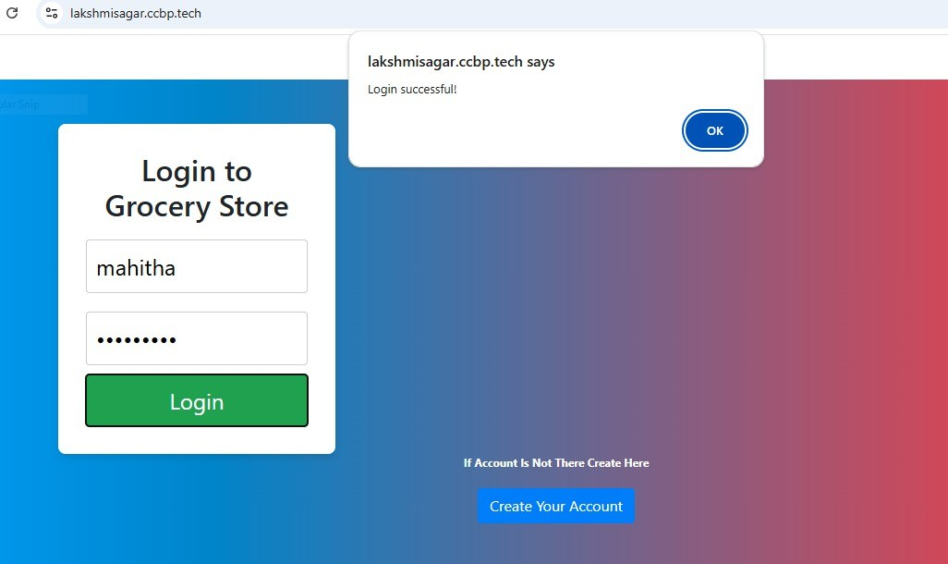

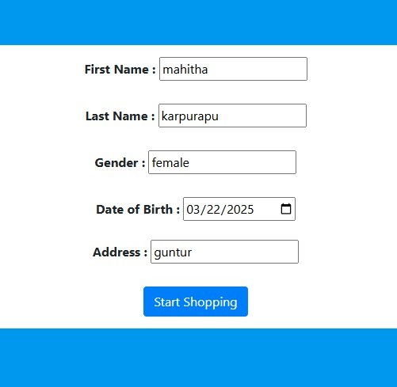

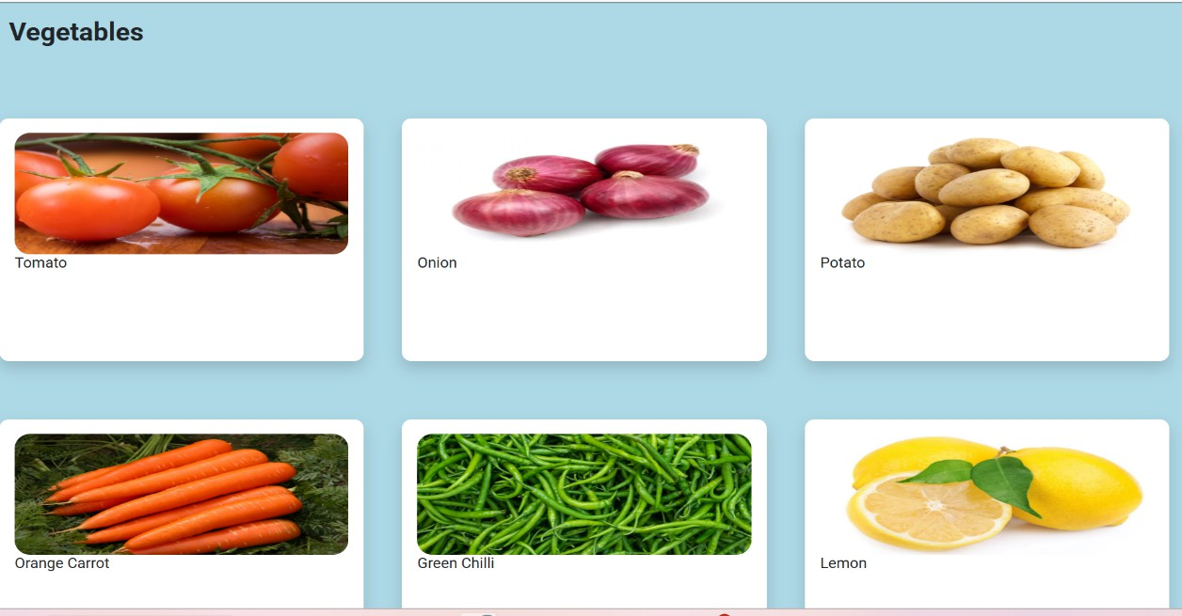

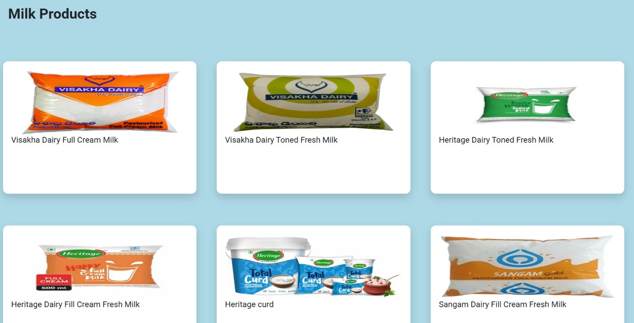

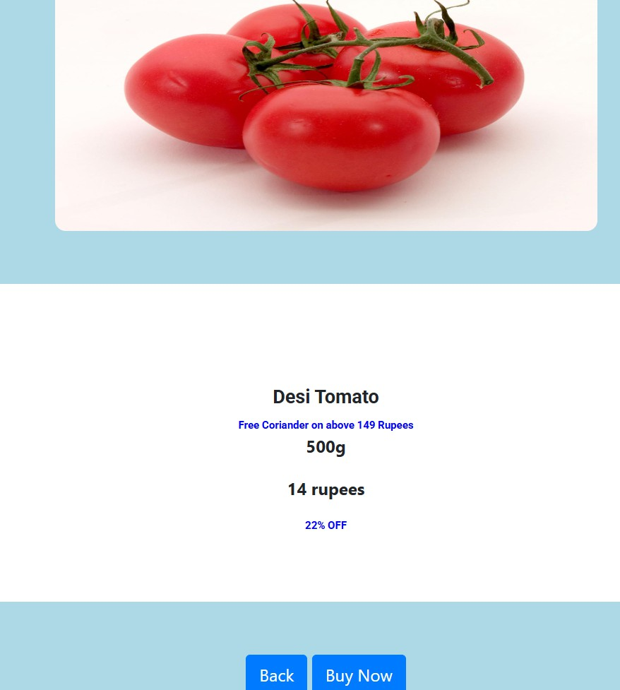

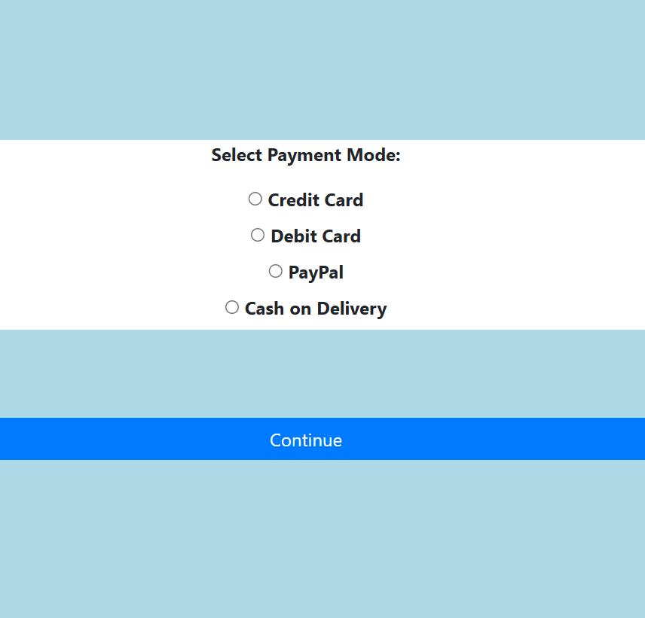


- Conclusion:
The shift towards online grocery shopping is inevitable due to the increasing need for convenience and efficiency. Our online grocery store offers a seamless and customer-friendly platform to purchase daily essentials effortlessly. By integrating technology, we enhance user experience, ensure quality service, and provide a competitive advantage in the digital marketplace. With a commitment to reliability, affordability, and innovation, our store aims to transform the grocery shopping experience for everyone.

References:
◻Chaffey, D. (2021). Digital Marketing: Strategy, Implementation, and Practice. Pearson Education. Available on Amazon.
- Laudon, K. C., & Traver, C. G. (2021). E-commerce: Business, Technology, and Society. Pearson Education. Available on Pearson.
◻Statista. (2025). Global E-commerce Market Revenue. Retrieved from https://www.statista.com.
- Turban, E., Outland, J., King, D., Lee, J. K., Liang, T.-P., & Turban, D. C. (2021). Electronic Commerce 2021: A Managerial and Social Networks Perspective. Springer. Springer Link.

- World Economic Forum. (2023). The Future of E-commerce: Trends and Insights. Retrieved from https://www.weforum.org.
◻Amazon Web Services. (2024). Building Scalable E-commerce Applications. Retrieved from https://aws.amazon.com/architecture.

Project Link: https://github.com/sagar28-kls/Grocery-shopping.git

